**Transcript from: Fair Isle: Plenty of puffins, not enough people - BBC News, 10.9.2017 (https://youtu.be/32gas5YYO1g)**

Interviewer/ narrator – **bold**

Interviewee(s) – normal font; M = male, F = female; M2 = 2nd male. F2 = 2nd female etc.

Transcribed by: 51985563

Duration of interview: from 00:06:44 to 00:13:13

Symbols used in interview transcript

|  |  |
| --- | --- |
| Symbol | Meaning |
| (*Recognise*) | A best guess at what was said |
| (???) | Missing word/phrase |
| …  (…)  *[laughs]* | A self-initiated pause  Superfluous speech/inaudible word  Verbatim interviews: actions and non-lexical conversation |
| **Incredibly**  **Incredibly** | Bold text indicates stressed/emphasised speech  Emphasis within speech already in bold text |
| (*00:01:03*) | Time stamped material that can’t be understood |

**Coding:**

Key themes:

1. Bird watching, 2. feelings, 3. economic side, 4. Fair Isle’s lifestyle

|  |  |
| --- | --- |
| [*Music and bird screaming*]  **N:** **Life here is ruled by arrivals and departures, every spring and autumn, the migrating birds return. There has been a bird observatory on Fair Isle for over 60 years. It is almost an industry. As the migrant birds arrive, so do the bird watchers. About 600 hundred every year. Paying hundreds, sometimes thousands of pounds for the privilege.**  M: “It is just when I (*spices at least*) join me back. It is just the air of expectation you just don’t know what’s gonna turn up here and it is a beautiful place as well get a nice sunny day the cliffs are just amazing; the scenery is just beyond anything. I have really never seen the country like this really.”  F: “I’ve been occasions (…) it’s quite exciting even though I don’t really know how the birds look like (…).”  M2: “…(*people in here keeps the transport the ones*) keep sort of level on the connections that we have. We have a good level of service, just because there’s a lot of visitors coming here. Keeps the shop going, I very much whether a shop would be viable here if it wasn’t for their have enough. (*Having to bend observatory*.) They keep us viable if we keep them viable. (…)”  M3: “This is one of the Farrell specials, you know so all these (*people you’re come to see*) basically Matt’s awaited waffle houses grasshopper was on us. “  M4: “Cool. It is not big.”  …  [*Background music*]  **N**: **The bird observatory has been collecting data for over 60 years, and because they have always used the same techniques, this information has become some of the most important migration and census data in Europe.**  (…)  M: “This is a willow Warbler there I was pretty much there one of the best places to see migration. Not just in Britain, but everywhere in the world. So, I feel incredibly lucky and privileged to get to work here and be a part of it.”  **N**: **That’s the only land mass for miles. Migrating birds use Fair Isle as a pit stop - at day and night.**  M: “The birds are pretty loud [*screaming birds*]. This is already stomp actual clapping, it is quite excited”. [*screaming birds*]  (…)  M: “So, what we are doing is putting a tiny, very lightweight metal ring onto the bird’s leg that has a unique number on it, and it means that if the bird is found elsewhere or trapped by anyone else and then we get the details of where our birds got and the people who catch it get the details of whether their bird came from.”  M and M: “(…) you just about make it now, it’s just almost beneath this …It’s one I think ones I always wanted to see was (…) and couldn’t have asked a better place for either.”  [*Chatting*]  (…)  (…)  M: “…(*my wife wouldn’t let me she’d hate*) it if she can’t go to John Lewis but weekend with a friend then. You know, if I won the lottery and I will in the big 175 million I’d might build come and build the John Lewis on here.”  (…)  **I**: **“If you will win a lottery, what would you do? “**  F: “That’s do you know, that’s it it’s a funny question.”  **I**: **“Would you stay, would you go?”**  F: “Oh for goodness, no I will stay. I’m living already where people that win the lottery ones. [*laughing*] No, I wouldn’t. “  (…)  M: I’m not into that thing, (*no*) I’ve got enough.  M: “If I win the lottery? Be a bloody American?! I don’t play the lottery.”  F: “Oh, I’d probably have to go a few places. But I probably come back because that’s the sort of place where I live. It does kind of have a little hold on you. “  M: Whale!  [Background music]  **N**: **Shon and Rachel only paid 500 pounds a year in rent. But their incomes are low too, and now, they have to learn what everyone else on Fair Isle has had before. How to (*make mice meat*) and how (*do croft*)?**  M: “I do feel very much at home and this is what I should be doing. You probably should have taken this so it’s not me, so here got maybe farming on the first place.”  [*Music and chattering*]  **I**: **“Are you still happy that you come here?”**  F: [*Enthusiastically*] “Yeah, massively! Well, I’ll certainly a me you know it is wonderful but there are challenges as well. The past couple of months have been quite tight. Things like the sheep feed you know, I mean that’s we’ve had two sheep feed deliveries that’s been about 200… “  END | Birds as a crucial part of the Island.  Importance of bird watchers for economic.  Feelings from a special landscape of the Faire Island.  Again, emphasising of tourism importance.  Fare Island is a home for unique species.  The international importance of bird observatory.  The special island’s location for birds watching also include special feelings.  The importance of Fairs Isle for the birds ecosystem.  Bird tracking methodology.  Answers on the lottery question and different attitudes towards it.  Specific lifestyle on the Fair Isle.  Despite the difficult lifestyle, people that live here are happy. |

# **Portfolio Task 2a: Qualitative Data Exercise – Annotated Image Exemplar**

Birds watching

Camera

Binocular

Birds watchers

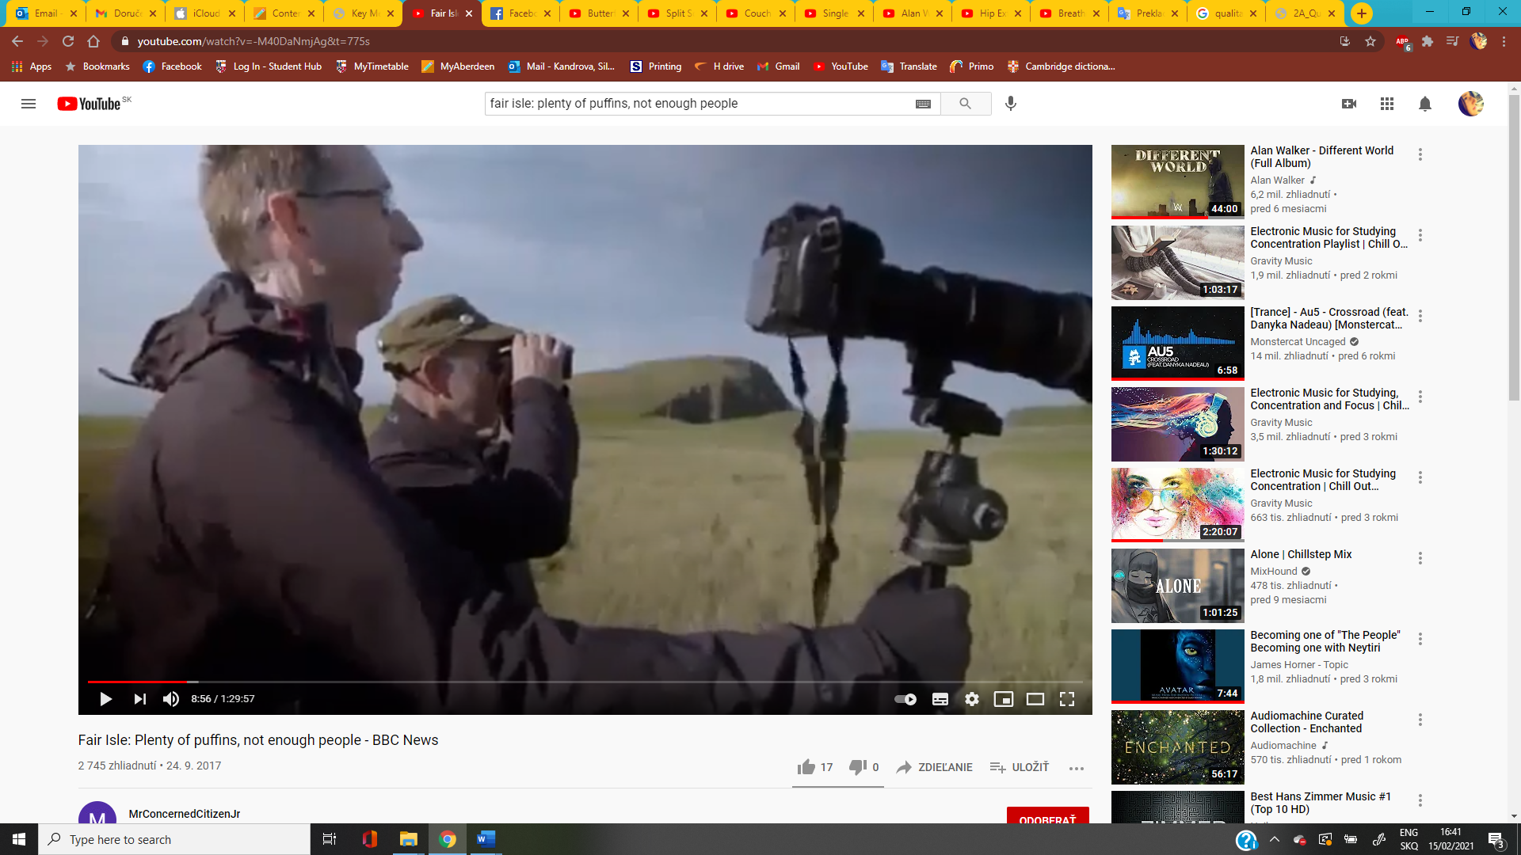

**Image from:** Fair Isle: Plenty of puffins, not enough people - BBC News, 10.9.2017

**Timestamp:** 00:08:56

**Available at:** https://youtu.be/32gas5YYO1g

**Annotated by:** 51985563

**Description:** Two men stands near the cliff and observe birds. One man uses binocular in order to see birds in better resolution. The second man with glasses holds tripod with a camera to take some pictures. Based on their clothes, we can assume that it is autumn or spring, with a nice sunny day.

**Audio data**

I coded data directly in Microsoft Word - using colour coding and table with two columns, in which I indicated key four themes of my interview. The right column of the table provides us quick overview of what is said in a particular section.

**Visual data**

I used this scene from the documentary because birds watching is an inseparable part of the Faire Isle. The main theme is bird watching and I consequently coded main elements of this activity- two men as bird watchers with key equipment – binocular and camera.